**A**

**PROJECT REPORT**

**ON**

**BIKE SHOWROOM MANAGEMENT SYSTEM**

**FOR MY WINGS HONDA**

**BY**

**OMKAR SATHE**

**HRUSHIKESH JAGTAP**

**BBA(CA)- SEM V**



**Maharashtra Education Society’s**

**GARWARE COLLEGE OF COMMERCE**

**( BBA(CA) DEPARTMENT)**

**KARVE ROAD , PUNE-411004**

**SAVITRIBAI PHULE PUNE UNIVERSITY**

**2018-2019**



**MAHRASHTRA EDUCATION SOCIETY’S**

**GARWARE COLLEGE OF COMMERCE**

KARVE ROAD, DECCAN GYMKHANA,

PUNE-411004

**Certificate**

This is to certify that Omkar Sathe and Hrushikesh Jagtap has successfully completed the project entitled “BIKE SHOWROOM MANAGEMENT SYSTEM” and has submitted the same to the satisfaction during the academic year 2018 – 2019 towards partial fullfillment of the degree ‘Bachelor of business administration computer application’,of the university of Pune.

(Project Guide) (BCA InCharge) (Principle)

(Internal Examiner) (External Examiner)

**ACKNOWLEDGEMENT**

It Gives us immense pleasure to express our sincere to ‘MY WINGS HONADA SHOWROOM’ .

I would like to express our sincere and deep gratitude to our internal project guide Mrs. Sampada Naiksatam, for her valuable guidance and suggestions.

I would also like to thank the coordinator for giving us guidance and timely help.

**Mr.** **Omkar** **Sathe**

**Mr.** **Hrushikesh** **Jagtap**

**(BCA Sem V)**

**TABLE OF CONTENTS**

**Chapter** **No.** **Title**

1. **Synopsis**
2. **Company** **Profile**
3. **Project** **Profile**
4. **Study of existing system**
   1. Study of existing system
   2. Client requirement specification
   3. Problems with existing system
   4. Fact finding methods
5. **Proposed System**
   1. Scope of proposed system
   2. Objectives of proposed system
   3. Feasibility study
   4. Hardware and Software Requirement
   5. System work flow
6. **System Analysis**
   1. Context Level Diagram
   2. Data Flow Diagram
   3. Entity Relationship Diagram
7. **System Design**
   1. Data Dictionary
   2. Table Design
   3. Form Design(With Input Values)
   4. Report Design(With Data)
   5. Demo
8. **System Limitations**
9. **Future Enhancements**
10. **Bibliography**

**Company Profile**

* **Name of the company** : My Wings Honda Showroom.
* **Address** : My wings , Dattawadi , Sinhgad road , Pune.
* **Service** : Selling Bikes , servicing of bikes , provide accessories& RTO passing
* **Establishment** : 2014
* **Time** : 09:30 AM to 08:00 PM
* Honda have 27 dealers in pune and My Wings is one of the them
* The showroom was established in the year of 2014. My wings honda in Dattawadi ,pune is one of the top player in the category motorcycle dealers of honda in pune. The belief that customer satisfaction is as important as their products and services.

**HONDA THE POWER OF DREAMS**

SYNOPSIS

|  |  |
| --- | --- |
| **Project Title:** | Bike Showroom Management system |
| **Name of the Company:** | My wings Honda Showroom |
| **Technology:** | VB 6.0  MS Access |
| **Team Members:** | OmkarSathe  HrushikeshJagtap |
| **Objectives:** | The objectives of proposed system is to automate the current manual system for availing all the benefits of computerization . The proposed system will work according to the standards laid down by the existing system.   * To develop a user-friendly system. * To reduce redundancy of data. * To reduce paperwork. * To provide data security. * To provide easy data operations. * To ease the process of editing & updating. * To keep a check on the data processed to avoid errors. * To provide authorized access to the system. |
| **Modules:** | 1. Login 2. Employee Details 3. Enquiry 4. Quotation 5. Bike details 6. Bill and payment 7. Services 8. RTO passing |

**Project Profile**

The main objective for developing this project Bike Showroom Management System can helps to maintain the customer information , payment details , bike information , payment details, insurance details ,take order, deliver order.

The project profile consist of Following :

**Enquiry of various models :**

This process includes introduction of various models of vanous vehicle is made for before customer. this also includes providing the customer with details quotation of vehicles. Customer will finalize the vehicle

**Booking of Vehicle :**

This process includes booking of vehicles It includes booking number customer name, contact number, address, vehicle name, model, delivery status etc .

**Payment Mode(Customer choice cash or loan) :**

It's complete on the customer's choice whether they will pay a hard cash or will take loan .

**Preparation of invoice:**

This will done in case of direct cash payment. It will include the customer's name invoice number, product code, product price &discount.

**Loan procedure :**

Document will be sent to bank & verifying that loan will be approved The documents include may be application, pan details etc.

**RTO Documentation :**

The documents necessary are accepted & will be sent to RTO for passing .

**Delivery of product :**

In these step the vehicle will be delivered to the customer .

**Issuing of number &smartcard :**

Number is issued in 4 days & smartcard is issued in 4 month by RTO.

**Study of Existing System**

1.The system followed in Yash Motors is partially manual & involves working on machine. The major goal of business are sales & services.

2. In this process starts with enquiry of various models prevailing in market & showroom respectively. The customer is provided with the details & overall quotations of the vehicle. Then customer finalize the vehicle.

3. Then the customer is asked if he/she is going to pay through cash or loan. If cash then invoice is prepared accordingly. If the loan is to be taken then approval from bank is required, after the approval arrangement is done.

4. Necessary documents are collected from customer for RTO & filled from & documentation are sent to RTO passing.

5. Vehicle is delivered to respective customer & number is issued within 4 days & smart card is issued within 4 months.

|  |  |
| --- | --- |
|  |  |

**Client Requirement Specification**

**Making an Quotation Form:**

The Client requires the quotation form to record the details about the customer name, address, phone number & also about the details of vehicle.

**Booking Form :**

Booking form is given at the time of booking procedure. The form shows that which client book , with all details & also include the payment information.

**Billing :**

It should provide recording of payment of vehicle to the customer in the printed form.

**Payment :**

1. By cash
2. By check
3. By loan
4. Installment

**RTO Form :**

When payment procedure is completed , the RTO form is filled & submitted to RTO office.

**Problems with Existing System**

The current system that is handled is truly manual . It hardly has anything to do with maintaining data on the computer . The problem of the existing system are:

* Tremendous paperwork
* No manpower to handle data
* Data is maintained in files
* Difficulty is searching of the records
* Tremendous time required

**Study of Proposed System**

The proposed system is amid to provide a much better approach to job Processing System. It reduce the manual efforts that are require in the processes . The system aims at providing accuracy and efficiency to the user The summarized data whenever required, is provided by the reports.

The scope of the proposed system is as follows :

* Master Maintenance :

Master maintenance contains terms dealing with the details of Client, Suppliers , Vehicles and company. This information is to be maintained by the administrator

* Transactions :

Transaction forms include forms of Bill and Purchase order

* Report :

All the data requires to be depicted through reports is aptly  shown in the system

The system aptly caters to the need of automation of the TWO  WHEELER SHOWROOM MANAGEMENT SYSTEM existing today

**TABLE DESIGN**

**Table no : 1**

**Login Master**

|  |  |  |  |  |
| --- | --- | --- | --- | --- |
| Column Name | Datatype | Size | Constraint | Description |
| LoginID | Number | 10 | Primary key | User id |
| UserName | Text | 20 | Not Null | User Name |
| LoginPassword | Number | 8 | Not Null | Login password |
| UserType | Text | 20 | Not Null | User Type |

**Table no : 2**

**Staff Master**

|  |  |  |  |  |
| --- | --- | --- | --- | --- |
| Column Name | Datatype | Size | Constraint | Description |
| StaffID | Number | 10 | Primary key | Staff Id |
| StaffName | Text | 30 | Not Null | Staff name |
| SUserName | Text | 30 | Not Null | User Name |
| Password | Number | 8 | Not Null | Password |
| PhNo | Number | 10 | Not Null | Phone number |
| Designation | Text | 20 | Not Null | Designation |

**Table no : 3**

**Customer Master**

|  |  |  |  |  |
| --- | --- | --- | --- | --- |
| Column Name | Datatype | Size | Constraint | Description |
| CustID | Number | 10 | Primary key | Customer ID |
| CustName | Text | 30 | Not Null | Customer Name |
| CustAddr | Text | 50 | Not Null | Customer Address |
| CustPhNo | Number | 10 | Not Null | Customer phone number |
| CustEmail | Text | 20 | Not Null | Customer Email Id |

**Table no : 4**

**Bike Master**

|  |  |  |  |  |
| --- | --- | --- | --- | --- |
| Column Name | Datatype | Size | Constraint | Description |
| BikeID | Number | 10 | Primary key | Bike Id |
| BikeNAme | Text | 20 | Not Null | Bike Name |
| BikeType | Text | 20 | Not Null | Bike Types |
| BikePrice | Number | 20 | Not Null | Bike Price |
| BikeColor | Text | 10 | Not Null | Bike |
| BikeModel | Text | 20 | Not Null | Bike Mld |

**Table no: 5**

**Enquiry Mater**

|  |  |  |  |  |
| --- | --- | --- | --- | --- |
| Column Name | Datatype | Size | Constraint | Description |
| EnquiryNo | Number | 10 | Primary key | Enquiry number |
| EnqDate | Date | 10 | Not Null | Enquiry date |
| BikeInterest | Text | 20 | Not Null | Bike interested |
| Category | Text | 20 | Not Null | Category |
| ModelColor | Text | 20 | Not Null | Model color |
| Name | Text | 30 | Not Null | Name |
| PhNo | Number | 10 | Not Null | Phone Number |
| Address | Text | 40 | Not Null | Address |
| EmailID | Text | 30 | Not Null | Email ID |
| Remark | Text | 50 | Not Null | Remark |

**Table no: 6**

**Booking Master**

|  |  |  |  |  |
| --- | --- | --- | --- | --- |
| Column Name | Datatype | Size | Constraint | Description |
| BookingNo | Number | 10 | Primary key | Booking number |
| BookDate | Date | 10 | Not Null | Booking date |
| CustName | Text | 30 | Not Null | Customer Name |
| CustAddr | Text | 40 | Not Null | Customer Address |
| BikeID | Number | 10 | Foreign key | Bike ID |
| BName | Text | 20 | Not Null | Bike Name |
| BModel | Text | 20 | Not Null | Bike Model |
| BPrice | Number | 10 | Not Null | Bike Price |
| Tax | Number | 10 | Not Null | Taxes |
| Remark | Text | 50 | Not Null | Remark |

**Table No: 7**

**Quotation Master**

|  |  |  |  |  |
| --- | --- | --- | --- | --- |
| Column Name | Datatype | Size | Constraint | Description |
| QNo | Number | 10 | Primary key | Quotation Number |
| QDate | Date | 10 | Not Null | Quotation Date |
| Name | Text | 30 | Not Null | Name |
| PhNo | Number | 10 | Not Null | Phone Number |
| BikeName | Text | 20 | Not Null | Bike name |
| BikeModel | Text | 20 | Not Null | Bike Model |
| BikeColor | Text | 20 | Not Null | Bike Color |
| BikePrice | Number | 10 | Not Null | Bike price |
| Tax | Number | 10 | Not Null | Taxes |
| Remark | Text | 50 | Not Null | Remark |

**Table No: 8**

**Bill Master**

|  |  |  |  |  |
| --- | --- | --- | --- | --- |
| Column Name | Datatype | Size | Constraint | Description |
| BillNo | Number | 10 | Primary key | Bill Number |
| BDate | Date | 10 | Not Null | Bill Date |
| CustName | Text | 30 | Not Null | Customer Name |
| PhNo | Number | 10 | Not Null | Customer phone number |
| BikeID | Number | 10 | Not Null | Bike ID |
| BColor | Text | 10 | Not Null | Bike color |
| Accessories | Text | 20 | Not Null | Bike accessories |
| RTOTax | Number | 10 | Not Null | RTO Taxes |
| InsuCharges | Number | 10 | Not Null | Insurance Charges |
| TaxCT | Number | 10 | Not Null | Tax charges total |

**NEED FOR COMPUTERIZATION**

The existing system is totally manual. All the necessary information is obtained from the manual process. It is fed to the computer. This involves the machine work.

The reports that are generated in the system also help to properly evaluate the data which forms an essential part of the system.

The data redundancy and data manipulation was also a necessary factor in the manual System. This also has been worked with in the system.

**FEASIBILITY STUDY**

The feasibility study helps to decide the various factors that are required to meet the needs of today's system.

Feasibility analysis involves the study of the economic, technical and behavioral 1 needs of today's system.factors in the system.

1.**Technical feasibility** comprises for the existing hardware and software and to what extent it can support the proposed system The person concerned in the system has the proposed requirements to meet the system in its complete vain.

2. **Economic feasibility** comprises the cost factor for implementing the system There is viably nothing to cost in the system.

3.**Behavioral feasibility** considers the acceptance of the system The person concerned understand the importance of having a system such as this and so is prepared to have this system.

Thus the proposed system is technically, economically as well as behaviorally feasible to be developed and implemented.

**NOMENCLATURE**

**Symbols are used in ERD**

Following are the symbol used for drawing the Entity Relationship Diagram

* Entity
* Relationship
* One **1**
* Many **M**

**Context Level Diagram**

Dispatchment of vehicle

Registration of order

Dispatchment of vehicle

Company

Company

Payment

Acceptence

Purchase order details

Proprietor

 Proprietor

Payment

Sales Report

Payment Detail

Booking

Product Delivery

Enquiry

Receipt

Customer

Bike Showroom Management System

Customer

payment

RTO

Bank

Documentation

Vehicle Details

Loan Scantion

Verified Document

Form Passing

Verification of document

Smart Card Registration

Verification Details

Bank

RTO

**DATA FLOW DIAGRAM**

Offers/Discount

Customer Details

Document Details

Company Details

Customer Details

Bike Details

Bike Details

Company Details

Customer

Proprietor

Company

CustomerMst

BikeMst

**1.0**

**Master**

**Maintainance**

Offers/Discount

Bike Details

Enquiry

Proprietor

Customer

Quotation

BikeMst

**2.0**

**Enquiry &**

**Quotation**

Quotation Details

Quotation Details

Customer Details

Offers/Discount

Quotation

Offers/Discount

Enquiry

Offers/Discount

Authorization Details

Documents Details

Booking Details

Customer Details

Customer Details

Quotation Details

Booking Details

Bike Availability

Proprietor

Customer

Quotation

BikeMst

**3.0**

**Vehicle**

**Booking**

CustomerMst

BookingMst

Payment mode, cash

BillMst

Authorization Details

Customer Details

Quotation Details

Booking Details

Amount , tax, offer

Proprietor

Customer

**4.0**

**Bill**

**Generation**

Payment

Bill

Receipt

CustomerMst

BookingMst

Quotation

Discount

Customer List

Bike Details

Cash Detail

BikeMst

Proprietor

Customer Details

Customer Detail

|  |  |
| --- | --- |
|  | CustomerMst |

Sales Report

Bill Details

**5.0**

**Report**

**Generation**

Booking

Enquiry

BillMst

Purchase Inward

Details

Bike Stock

Purchase Inward

Enquiry Details

Booking Details

Booking Report

Feedback Report

Quotation Details

Quotation

**ENTITY RELATIONSHIP DIAGRAM**

gives

has

gives

Sales person

for

handle

Enquiry

Quotation

booking

does

vehicle

Purchase of order

for

gets

customer

gets

bill

has

color

model

1

M

1

1

1

**SYSTEM LIMITATIONS**

Every system has its own functionalities concerned with a particular process that it comprises.

Taking this into concern, every system mast consider the core functionality of the system that manipulate the system efficiently.

The system is effective considering the functional part it has to perform. But every system has its own advantages and limitations.

The limitations for the Two Wheeler Showroom Management System are:

* The system may require changes in certain data after a phase. This cannot be facilitate at an early stage for the system.
* The system cannot provide security to data that is managerially important .
* Lots of paper work required.

**FUTURE ENHANCEMENTS**

Every system cannot be perfect in the processing of data that is required all the time.

Every system requires some enhancements to be done to keep its functionality intact or in some instances also improve the same.

The future enhancements for this system are:

Data security is a major concern.

The administrator should be able to modify the data that is requires every time.

Understanding possible prospects in the system and preparing the requirements accordingly.

These future enhancements would help to better know the requirements to be met in the time near.

**BIBLIOGRAPHY**

* VB 6.0
* MS Access
* Software Engineering

**Login Form**

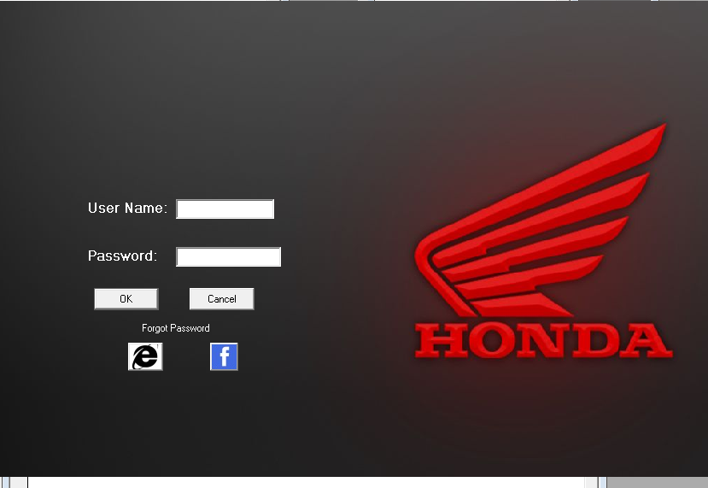

**MDI Form**



**Bike Details Form**

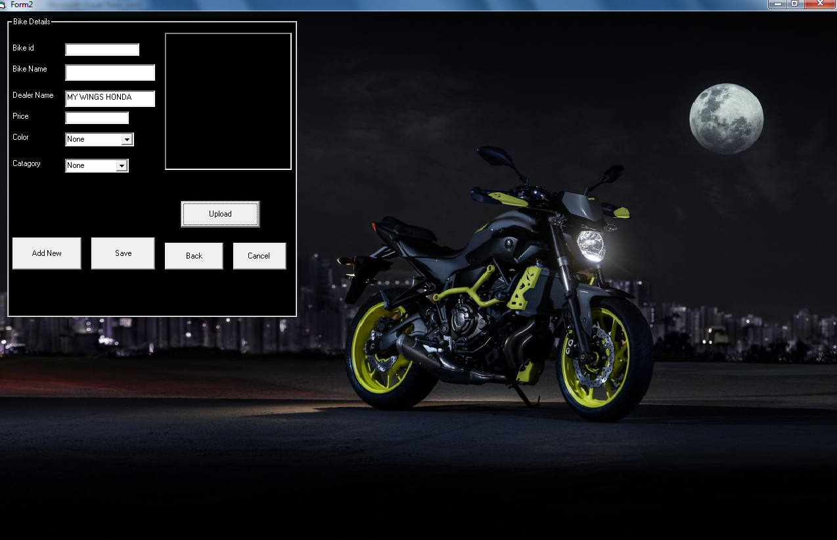

**Employee Details Form**

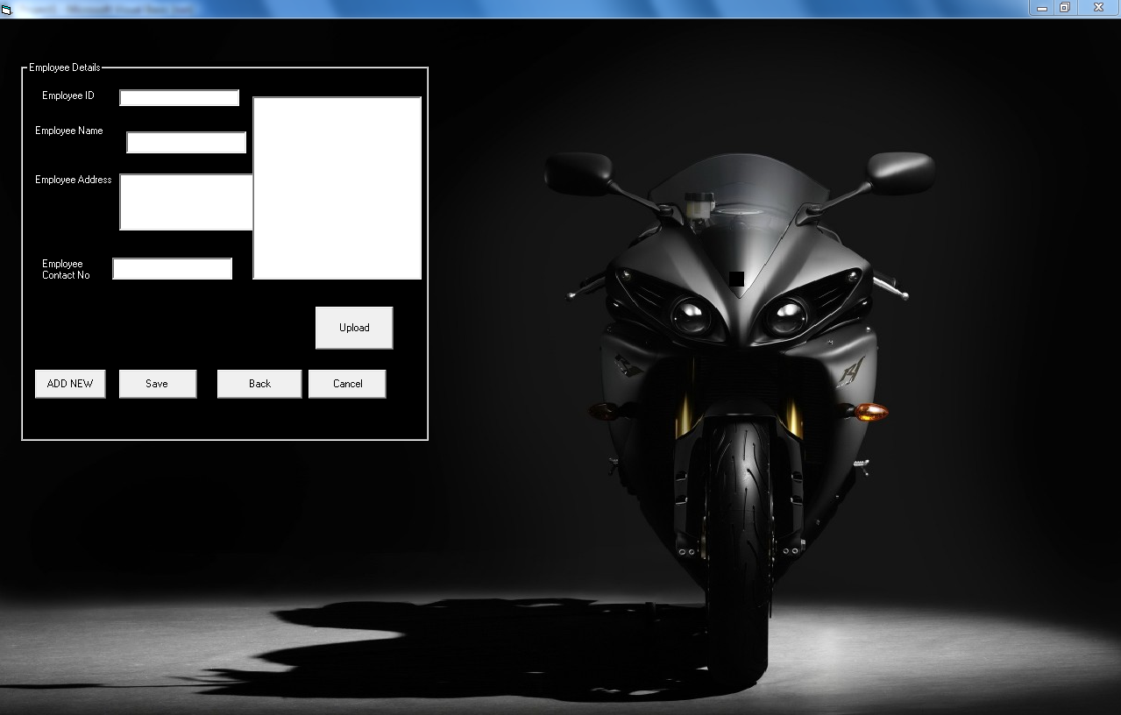

**Customer Details Form**

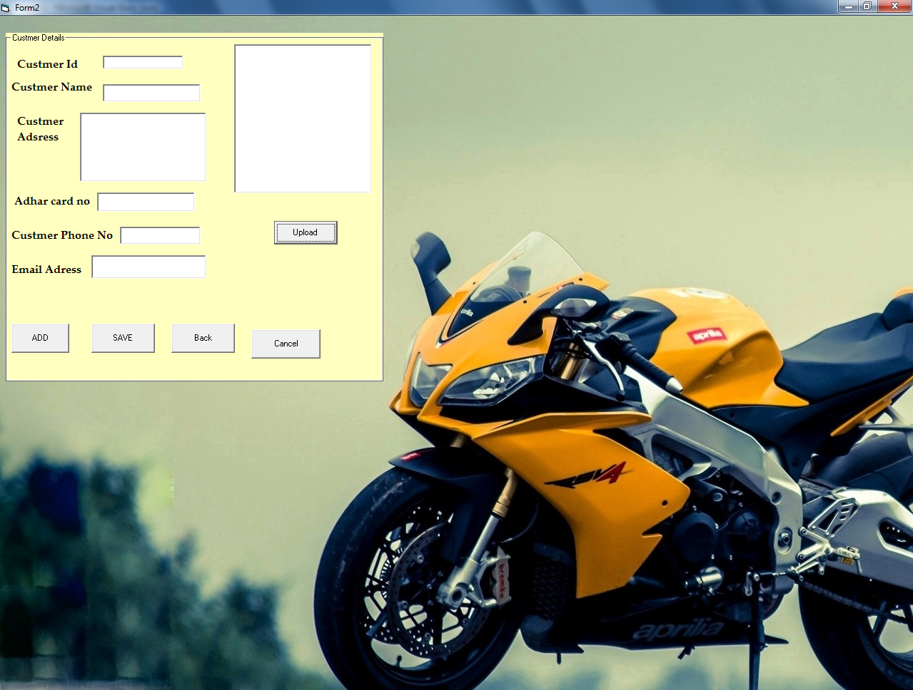

**Enquiry Form**

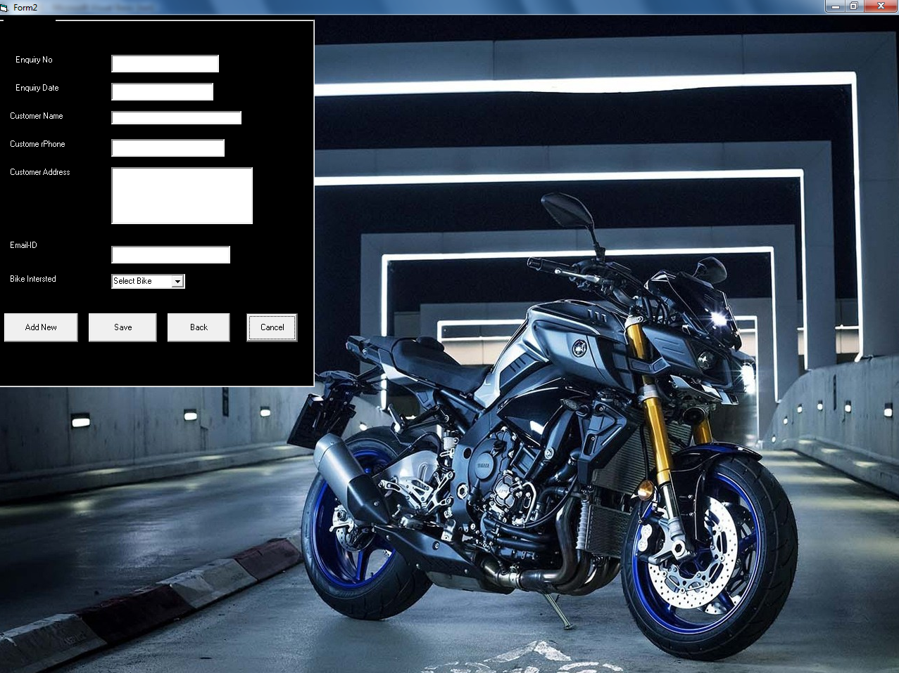

**EMI Form**

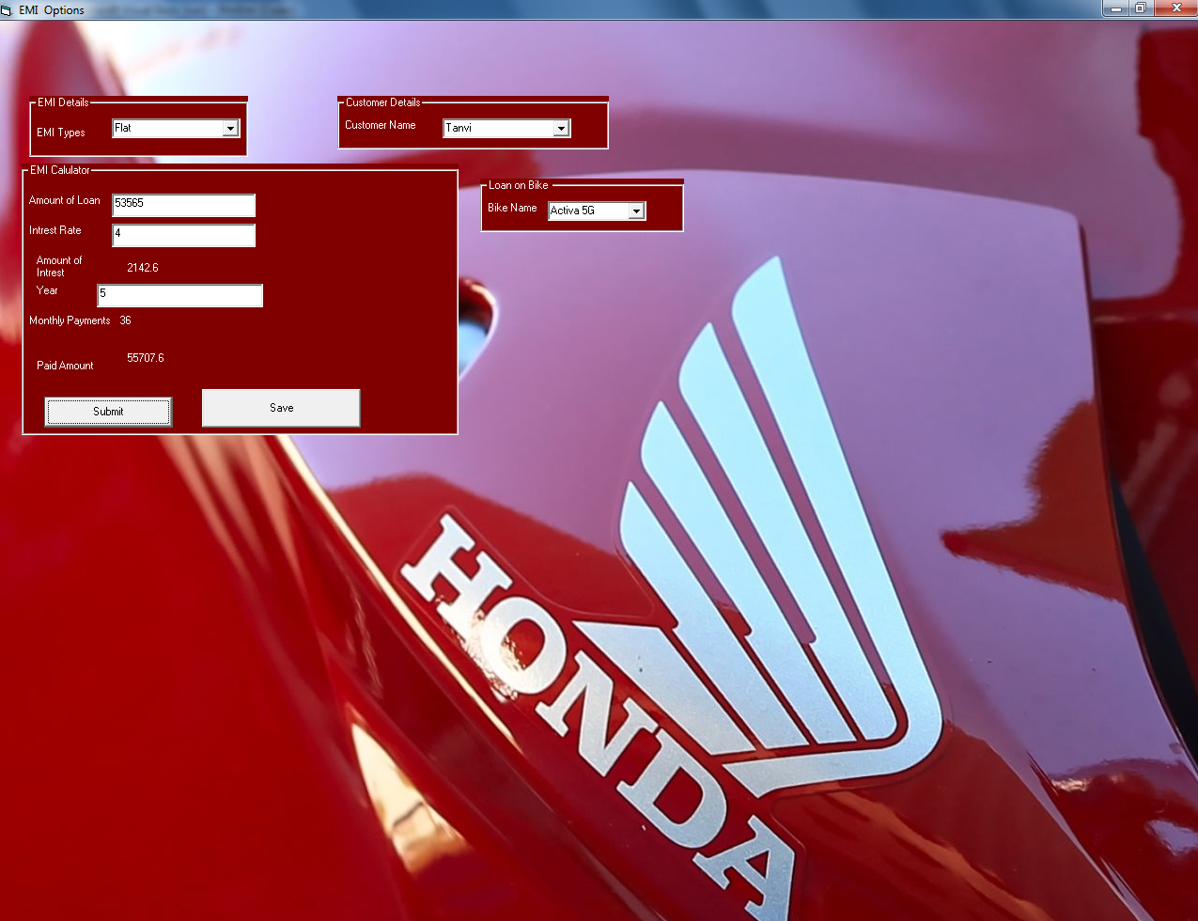

**Bike Search Form**

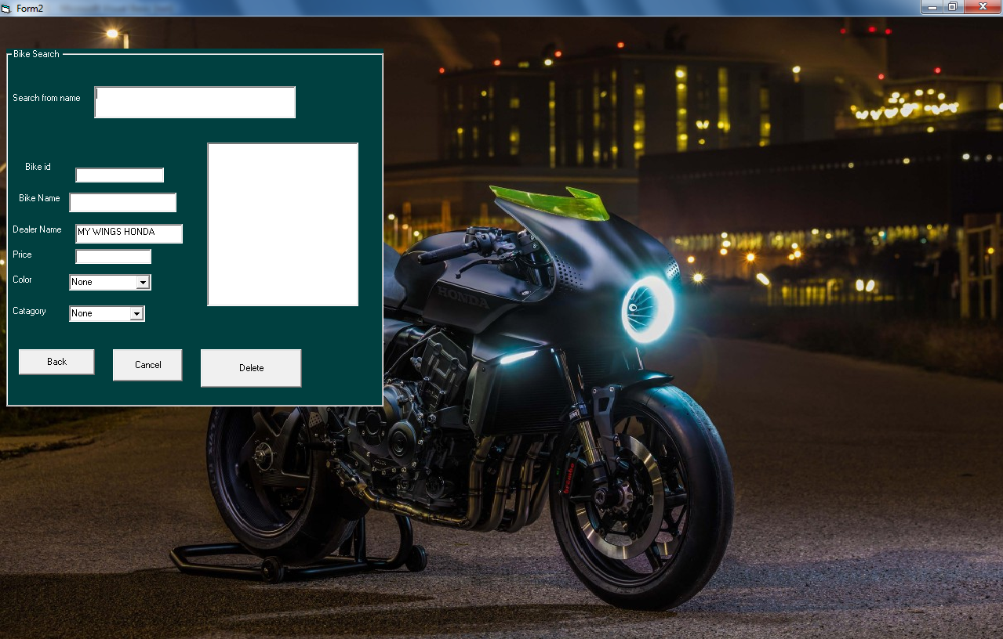

**Employee Search Form**

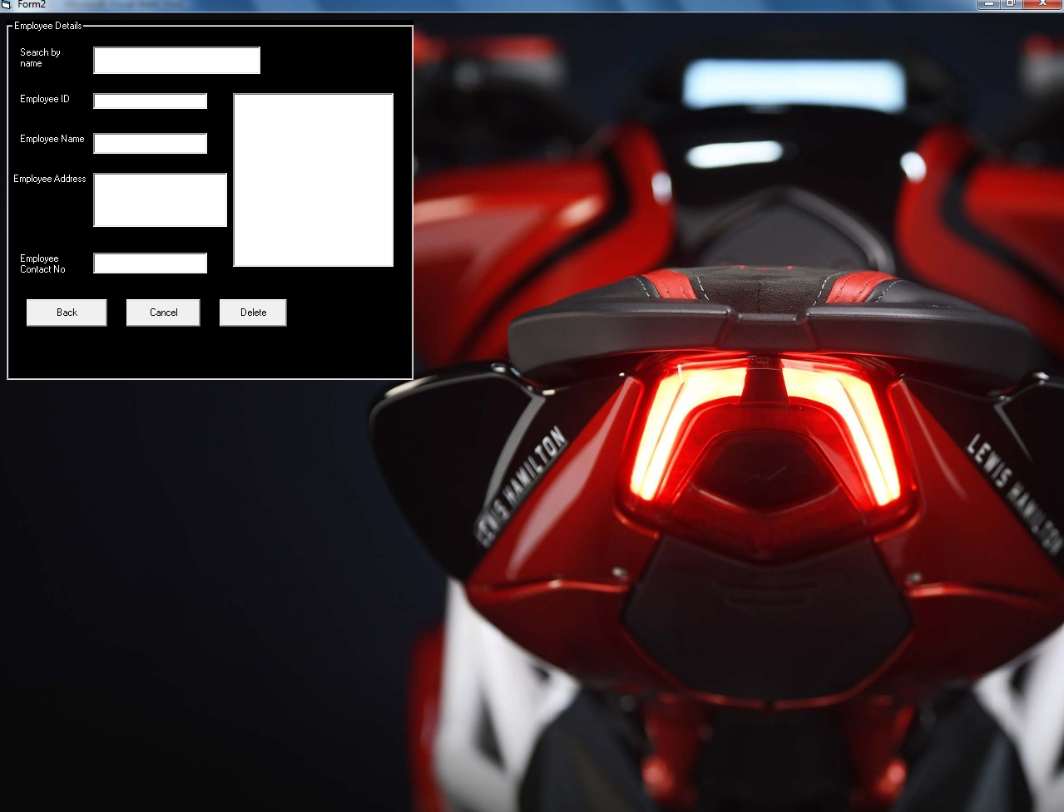

**Customer Search Form**

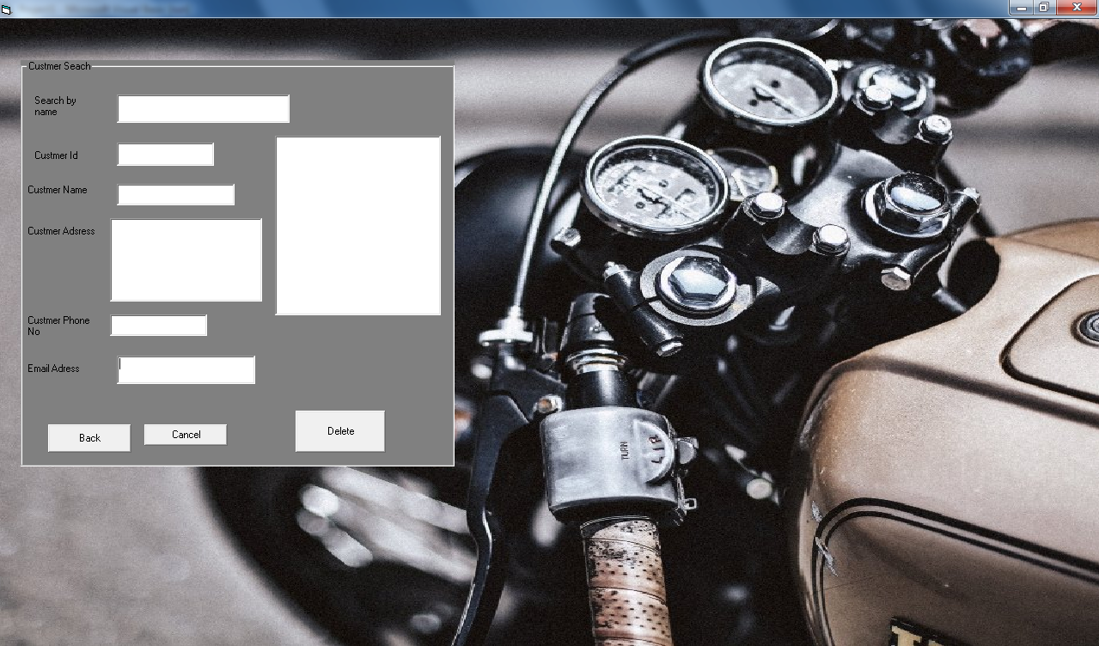

**Change Password Form**

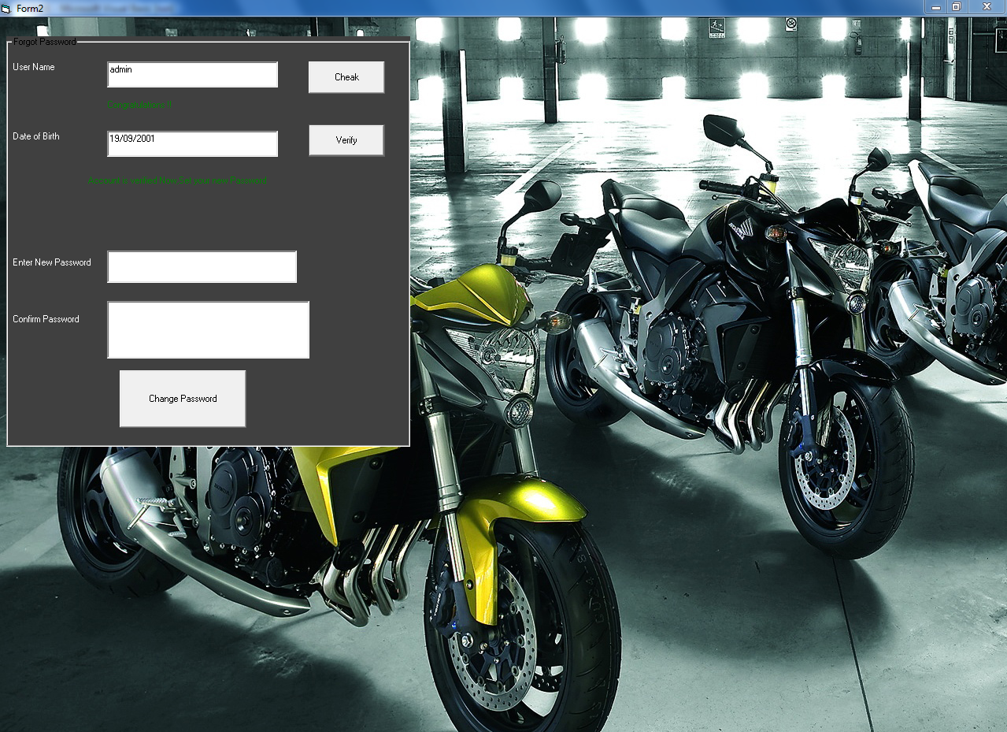

**Quotation Form**

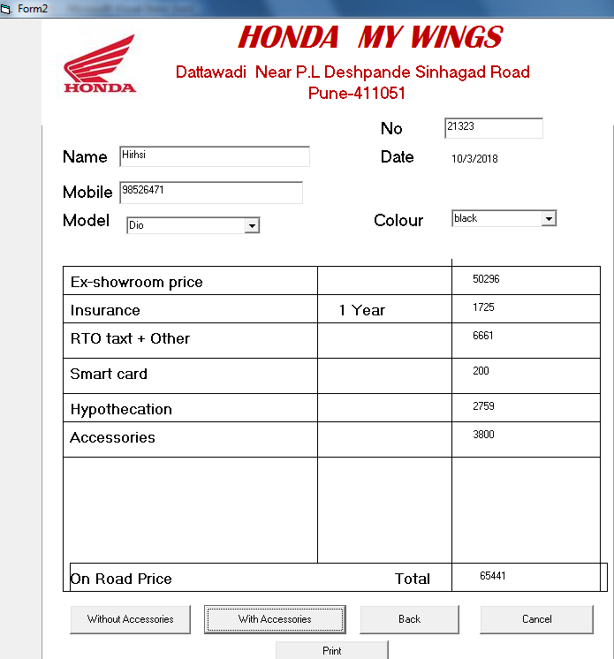

**Bill Generation Form**

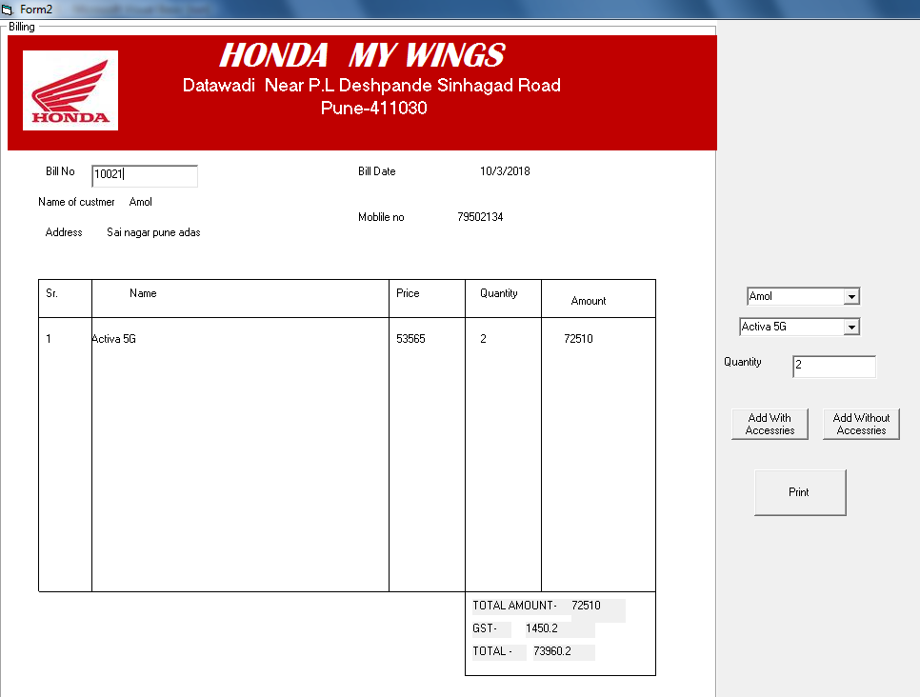

**Bike Report**

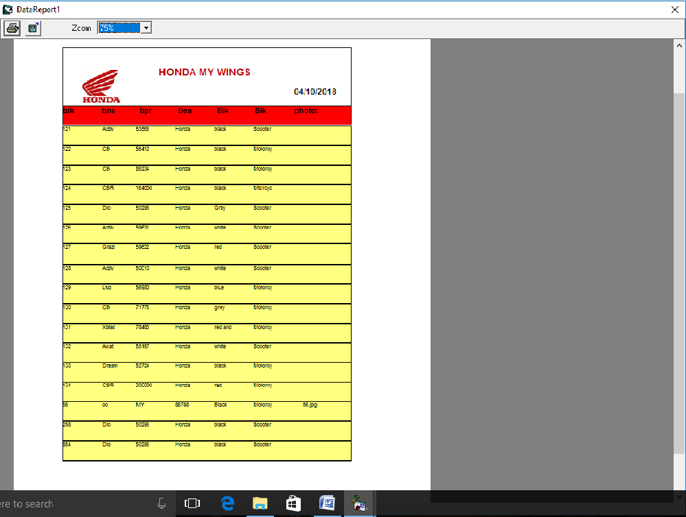

**Employee Report**

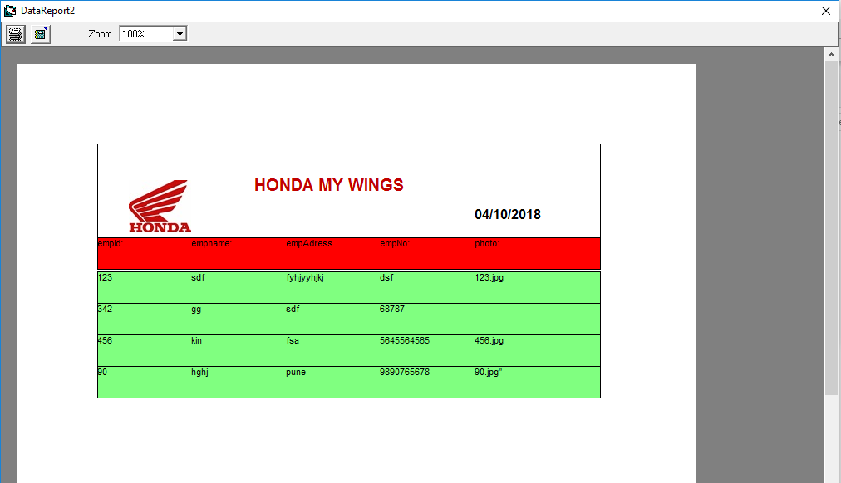

**Customer Report**

